It is possible to watch the flow of how the browser run in a selenium grid. For that you need to click on that icon and after that you will se the pop up. The password is: secret.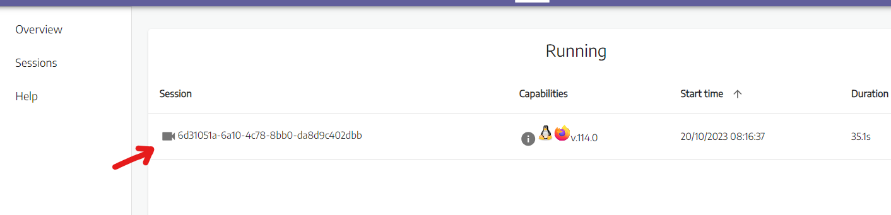

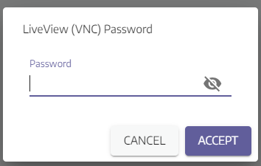

<- - In order to do not enter the password every time we can disable it in .yaml file with the instruction: - SE_VNC_NO_PASSWORD=1

yaml file:

